Onion Root Mitosis
Standards: B.4.4, AP.1.2, SEPS.1, SEPS.4, SEPS.5
Materials:
Microscopes
Onion root tip slides
Jones Agro Science contacted area science teachers for help with a new compound they are developing. This compound can stop plant growth by disrupting mitosis during one of the stages of mitosis, thus stopping a plant from growing. This compound can only stop mitosis at one stage (prophase, metaphase, anaphase, or telophase), so to make it as effective as possible Jones Agro needs to know what stage of mitosis takes the longest. This compound will be a new generation of weed control and can be made specific to one plant species at a time and is environmentally friendly. The problem is the Jones Agro scientists need to know how long each stage of mitosis lasts. In order to do that they need a huge data set to work with and that is where they need our help.
Jones Agro has sent us onion root tip slides so we can collect data on how long an onion root spends in each phase of mitosis. We already know that a developing plant cell spends 24hrs in the cell cycle. By counting how many cells are in each phase of the cell cycle we can determine how long each phase of the cell cycle lasts.
Procedure
- Obtain a prepared slide of an onion root tip. Hold the slide up to the light to see the pointed ends of the root sections. This is the root tip where the cells were actively dividing.

- Place the slide on the microscope stage with the root tips pointing away from you. Using the 4X objective and the focus adjustment, obtain the clearest image possible on the laptop. Now, repeat this step for the 10X objective. Repeat steps again for the 40X objective. Just above the root “cap” is a region that contains many new small cells. The larger cells of this region were in the process of dividing when the slide was made. These are the cells that you will be observing.

- As you look at the cells of the root tip, you may notice that some cells seem to be empty inside (there is no dark nucleus or visible chromosomes). This is because these cells are three dimensional, but we are looking at just thin slices of them. We want to continue to look at the cells, but we will ignore any where we cannot see the genetic material (dark areas).

- Starting at the tip of the root, just up from the root cap, follow a line of cells up calling out to your partner what stage each cell is in. When you get to the top of a column of cells go back to the tip and repeat the procedure for the next column of cells. Record your observations in the table provided below.

- Repeat step 5 until you have observed and recorded 50 cells and what stage in the cell cycle they are in.

 | Interphase | Prophase | Metaphase | Anaphase | Telophase | Total
Number  of cells |  |  |  |  |  | 50
Percent  Of cells |  |  |  |  |  | 100%
Minutes  In phase |  |  |  |  |  | 1440

The chart below will help you identify the different stages of mitosis in the onion root tip:
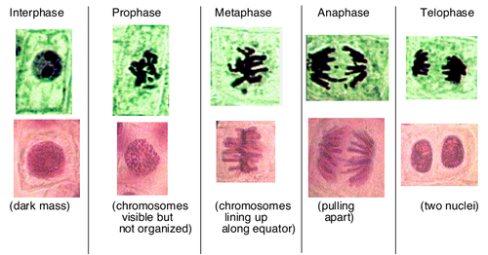

Onion Root Tip Diagram
